# 

# 

# Project Plan

**Group 2**

John Alabasinis - 22090614  
Jana Nasrallah - 22079884  
Salman Rashid - 22080099

**Professional Experience**

# 

# Table of Contents

**Group Details 2**

**Work Breakdown Structure 3**

**Project Related Risks 4**

**Project Related Constraints 5**

**Group Milestone Plan 6**

**Individual Task List 7**

**Communication Plan 10**

**Gantt Chart 11**

# 

# Group Details

|  | **Skills** | **Strengths** | **Weaknesses** |
| --- | --- | --- | --- |
| **John** | Time Management  Fast Learner  Team Collaboration | Communication  Problem solving  Hardworking | Programming |
| **Jana** | Team Collaboration  Adaptability  Writing Documentation | Independent Self-motivated  Organised | Programming  Second-guessing |
| **Salman** | Leadership  Team Collaboration  Documentation | Communication | Programming |

# Work Breakdown Structure

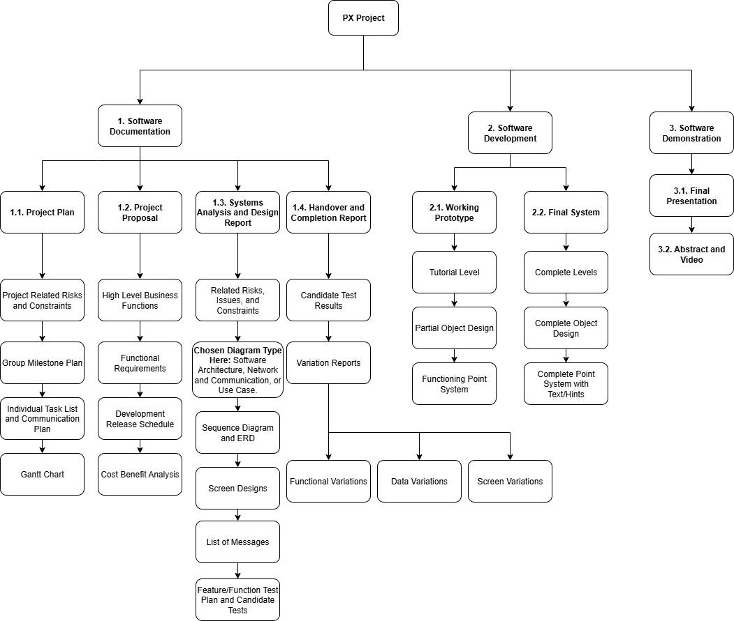

# Project Related Risks

|  | **Risk** | **Mitigation Strategies** | **Impact Level** |
| --- | --- | --- | --- |
| **1** | Poor Communication | Establish communication from the beginning with confirmation. Set up regular meetings, use collaborative tools, and assign clear roles and responsibilities. | High |
| **2** | Unrealistic Deadlines | Involve the entire group in the planning, and leave room for delays. | High |
| **3** | Technical Issues | Ensure there are backups of reports and prototypes when starting, and choose reliable technology tools. | Medium |
| **4** | Team Skills Gap | Ensure that the experienced member is assigned to a responsibility that they are familiar with. If this isn’t possible, provide support and guidance throughout. | Medium |

# Project Related Constraints

|  | **Constraint** | **Mitigation Strategies** | **Type** |
| --- | --- | --- | --- |
| **1** | Limited Access to Users for Feedback/Testing | Schedule early user development, simulate personas | Scope/Quality |
| **2** | Fixed Deadline | Add more resources and utilise more tools early on. Prioritise important features and tasks early on. | Time |
| **3** | High Quality Expectations | Define quality standards early and perform regular quality assurance testing. | Quality |
| **4** | Limited Team Size and/or Skill Gap | Support the team member with the skill gap early on, and maximise tools and resources for the project. | Resources |
| **5** | Compliance Restrictions | Review the relevant standards and procedures from the start. | Legal/Regulatory |

# Group Milestone Plan

| **Milestone** | **Main Responsibility** | **Planned Date** | **Actual Date** |
| --- | --- | --- | --- |
| Project Plan | John, Jana, Salman | 19/07/2025 | 20/07/2025 |
| Project Proposal | John, Jana, Salman | 26/07/2025 |  |
| Working Prototype | John, Jana, Salman | 8/08/2025 |  |
| Systems Analysis and Design Report | John, Jana, Salman | 16/08/2025 |  |
| Final System | John, Jana, Salman | 17/09/2025 |  |
| Handover and Completion Report | John, Jana, Salman | 20/09/2025 |  |
| Project Abstract | John, Jana, Salman | 25/09/2025 |  |
| Project Video | John, Jana, Salman | 25/09/2025 |  |

# Individual Task List

| **Team Member: John Alabasinis** | | | | |
| --- | --- | --- | --- | --- |
| **Task** | **Deliverable** | **Start Date** | **End Date** | **% Complete (as of reporting)** |
| Item 1.1.4: **Group Milestone Plan** | Project Plan | 17/07/2025 | 20/07/2025 | **100%** |
| Item 1.1.6: **Communication Plan** | Project Plan | 16/07/2025 | 20/07/2025 | **100%** |
| Item 1.1.7: **Gantt Chart** | Project Plan | 19/07/2025 | 20/07/2025 | **100%** |
| Item 1.2.2: **Functional Requirements (User Stories)** | Project Proposal | 21/07/2025 | 27/07/2025 | **0%** |
| Item 1.3.4: **Network and Communication Diagram** | Systems Analysis and Design Report | 1/08/2025 | 17/08/2025 | **0%** |
| Item 1.3.7: **User Story Acceptance Criteria** | Systems Analysis and Design Report | 28/07/2025 | 31/07/2025 | **0%** |
| Item 1.3.11: **Screen Design** | Systems Analysis and Design Report | 3/08/2025 | 17/08/2025 | **0%** |

| **Team Member: Jana Nasrallah** | | | | |
| --- | --- | --- | --- | --- |
| **Task** | **Deliverable** | **Start Date** | **End Date** | **% Complete (as of reporting)** |
| Item 1.1.1: **Work Breakdown Structure** | Project Plan | 18/07/2025 | 20/07/2025 | **100%** |
| Item 1.1.2: **Project Related Risks** | Project Plan | 14/07/2025 | 20/07/2025 | **100%** |
| Item 1.1.3: **Project Related Constraints** | Project Plan | 14/07/2025 | 20/07/2025 | **100%** |
| Item 1.2.1: **High-Level Business Functions** | Project Proposal | 21/07/2025 | 27/07/2025 | **0%** |
| Item 1.2.4: **Cost-Benefit Analysis** | Project Proposal | 21/07/2025 | 27/07/2025 | **0%** |
| Item 1.3.1: **Risks and Issues & Constraints Related to the System** | Systems Analysis and Design Report | 11/07/2025 | 17/08/2025 | **0%** |
| Item 1.3.12 **List of Messages** | Systems Analysis and Design Report | 28/07/2025 | 17/08/2025 | **0%** |
| Item 1.3.3: **Sequence Diagram** | Systems Analysis and Design Report | 4/08/2025 | 17/08/2025 | **0%** |

| **Team Member: Salman Rashid** | | | | |
| --- | --- | --- | --- | --- |
| **Task** | **Deliverable** | **Start Date** | **End Date** | **% Complete (as of reporting)** |
| Item 1.2.2: **Development Release Schedule** | Project Proposal | 21/07/2025 | 27/07/2025 | 0% |
| Item 1.3.2: **Systems/Software Architecture Diagram** | Systems Analysis and Design Report | 27/07/2025 | 17/08/2025 | 0% |
| Item 1.3.4: **Entity Relationship Diagram** | Systems Analysis and Design Report | 27/07/2025 | 17/08/2025 | 0% |
| Item 1.3.7: **Feature/Function Test Plan** | Systems Analysis and Design Report | 27/07/2025 | 17/08/2025 | 0% |
| Item 1.3.11: **Candidate Tests** | Systems Analysis and Design Report | 27/07/2025 | 17/08/2025 | 0% |

# 

# Communication Plan

| **Meeting Type** | **Length** | **First Meeting** | **How Often** | **Number of Meetings Planned** | **Location/Mode** |
| --- | --- | --- | --- | --- | --- |
| Client Meetings | 60 mins | 18/07/2025 | Fortnightly, Friday 3pm | 6 | Online/Zoom |
| Academic Supervisor Meetings | 60 mins | 18/07/2025 | Weekly, Friday 4pm | 10 | Online/Zoom |
| Team Meetings | 30 mins | 17/07/2025 | Weekly,  Thursday 2pm | 10 | Online/Zoom |

# Gantt Chart

